Plant Image Report
Trend in combined hyperspectral imaging and AI based analysis for Field application
Gil-Dong Hong^{a,b}, Joshua Cheng^{b}, Sofia Lee^{c}, Zayd Olofsson^{d}, Leader Mo^{a,d,*}
ªResearch Institute a, City a, Country a
^{b}Research Institute b, City b, Country b
^{c}Research Institute c, City c, Country c
^{d}Research Institute d, City d, Country d
ARTICLE HISTORY
ABSTRACT
The abstract of paper must include: contextual background with the research; clear objectives; concise methodology overview; precise key findings; principal conclusions addressing the initial problem; and broader implications. This single paragraph (150-200 words) requires logical progression, accessible terminology, appropriate tense usage, and demonstrated significance. The abstract functions as both summary and persuasive instrument, demanding precision in every sentence to establish the work's value within competitive scientific discourse.
Received 25 October 2024
Accepted 2 April 2025

KEYWORDS
3-6 keywords

Introduction
The introduction of a paper should include: relevant background literature establishing the research field; identification of knowledge gaps or problems; clear research aims and hypotheses; brief overview of methodological approach; significance and novelty of the work; and a concise outline of the paper's structure. Previous research examples can be included when necessary.
The introduction builds progressively from broad context to specific focus, justifying the research while placing it within the existing scientific framework. Each element should contribute to a compelling narrative that convinces readers of the work's importance and logical foundation.
Citations within the main text should follow APA style format. In-text citations should include author surname(s) and publication year (e.g., Smith, 2023 or Smith & Jones, 2023). For three or more authors, use the first author's surname followed by "et al." (e.g., Smith et al., 2023). Direct quotations require page numbers (Smith, 2023, p. 45).

Materials and Methods
Subtitle 1 of Materials and Methods
The Materials and Methods section should be organized with clear subtitles that separate distinct methodological components. This structured approach enhances readability and allows readers to easily locate specific protocols. Each subtitle should address a different aspect of your methodology (e.g., "Sample Collection," "Experimental Design," "Analytical Techniques," "Statistical Analysis").
For each subtitled section:
Provide sufficient detail for replication by other researchers
Present methods in chronological order when possible
Include specifications of equipment, materials, and reagents with manufacturer details
Describe experimental controls and validation procedures
Detail statistical approaches and software used for analysis
The Materials and Methods must balance comprehensive reporting with concise writing, avoiding unnecessary elaboration while ensuring all critical procedures are documented. For established methods, brief descriptions with appropriate citations are sufficient, while novel or modified techniques require more thorough explanation.
This section serves as the technical foundation of your research and directly impacts the credibility of your results. The subtitle organization allows readers to quickly assess methodological rigor and locate specific protocols relevant to their interests. The citation method should follow APA style. Please follow the guidelines presented in the Introduction.
Include figures and tables where necessary to enhance explanations. Figures and tables must ensure reader readability and should be numbered sequentially (e.g., Figure 1, Figure 2, Table 1, Table 2) with appropriate descriptions. For complex figures with multiple elements, provide individual explanations through alphabetical labeling (e.g., a, b, c). Any emphasis markings or highlights in figures require additional explanation. When inserting figures or tables, detailed descriptions must be provided in the main text to properly contextualize and interpret the visual information presented.
The figures (Figure 1) and tables (Table 1) presented were format examples only and have not been scientifically validated.
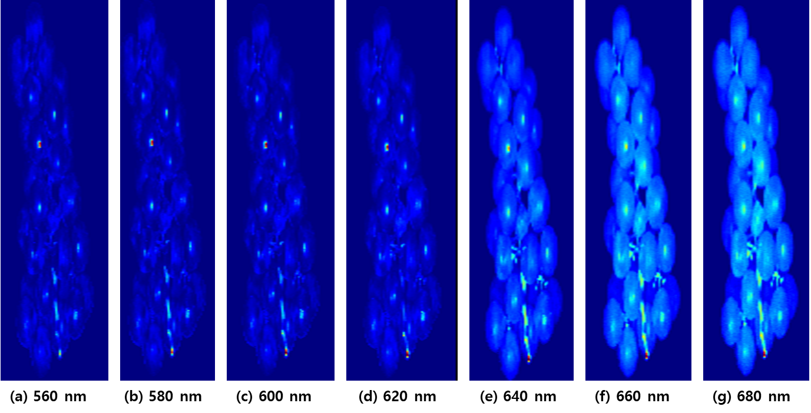
Figure 1. Hyperspectral imaging of grape at visible light wavelengths: (a) 560 nm; (b) 580 nm; (c) 600 nm; (d) 620 nm; (e) 640 nm; (f) 660 nm; (g) 680 nm.

Table 1. Spectral characteristics of grape at VIS-NIR hyperspectral imaging
Wavelength (nm) | Spectral features | Application
560 | Low contrast, minimal absorption, Green light absorption minimum | Baseline reference, structural analysis
580 | Slightly increased contrast, Transition toward yellow spectrum | Early stress detection, pigment analysis
600 | Moderate contrast, emerging patterns, Orange-red transition zone | Carotenoid assessment, early senescence detection
620 | Enhanced definition of cellular structures, Beginning of chlorophyll absorption band | Cell morphology studies, vitality assessment
640 | High contrast, clear cellular boundaries, Strong chlorophyll absorption | Photosynthetic efficiency analysis, stress mapping
660 | Maximum intensity, bright cell structures, Peak chlorophyll absorption | Photosynthetic activity quantification, NDVI calculations
680 | Intense brightness, defined structures, Near chlorophyll fluorescence emission | Photosystem II efficiency, plant health monitoring

Subtitle 2 of Materials and Methods

Subtitle 3 of Materials and Methods

Results and Discussion
Subtitle 1 of Results and Discussion
The Results and Discussion section should present your findings logically and interpret their significance. You may organize this as either a combined Results and Discussion or as separate sections, depending on journal guidelines and research complexity.
For Results:
Present findings objectively without interpretation
Organize data in a logical sequence (chronological, by hypothesis, or by importance)
Use tables and figures to highlight key results, ensuring each is numbered and referenced within the text
Include appropriate statistical analyses and significance levels
Focus on patterns, trends, and notable observations
For Discussion:
Interpret results in context of your research questions and hypotheses
Compare findings with previous research, explaining similarities and differences
Address unexpected results and limitations honestly
Propose mechanisms or explanations for observed phenomena
Discuss broader implications and applications of your findings
Subsequently, future research directions may be discussed, but exercise caution against overinterpretation of results
Acknowledge unexpected results and limitations
Avoid overinterpreting data or making claims beyond what results support
Throughout this section, maintain clear connections between your data and interpretations, ensuring each conclusion is supported by specific evidence. The narrative should build toward addressing your initial research objectives while positioning your work within the broader scientific context.

Subtitle 2 of Results and Discussion

Subtitle 3 of Results and Discussion

Conclusions
The conclusion should evaluate whether your initial objectives and hypotheses were fulfilled. Begin by explicitly revisiting your research goals and hypotheses as presented in the introduction. Systematically assess the degree to which each objective was achieved, supported by specific evidence from your results. Discuss any hypotheses that were confirmed, partially supported, or rejected, explaining the implications of these outcomes. Address any unexpected findings and their significance to your research questions. This critical examination demonstrates scientific rigor and intellectual honesty, while providing a framework for contextualizing your contributions within the broader field. The conclusion should present a balanced assessment that acknowledges both the strengths of your findings and any limitations, creating a complete narrative arc from your initial research questions to final outcomes.

Acknowledgments
Express gratitude to individuals, organizations, or institutions that provided assistance (technical help, advice, materials) but don't qualify for authorship. Include grant acknowledgments if required by funding agencies.

Author Contribution
Detail each author's specific contributions using the CRediT taxonomy (Conceptualization, Methodology, Investigation, etc.). Clearly state who did what aspects of the research, analysis, and manuscript preparation.

Ethical Approval
The Ethical Approval section is only necessary when your research involves elements that require ethical oversight or approval. State all relevant ethical approvals obtained for the research, including IRB/ethics committee names, protocol numbers, and dates. For animal studies, confirm compliance with institutional and national guidelines.

Disclosure Statement
Declare any potential conflicts of interest, financial or non-financial, that might be perceived as influencing the research. If none exist, explicitly state "The authors declare no conflicts of interest."

Funding
List all funding sources with grant numbers and the role of funders in the research. Include both financial support and in-kind contributions. If no external funding was received, state "This research received no external funding." Please refer to the specific funding acknowledgment guidelines of each institution.
When acknowledging funding, consult each funding agency's preferred citation format. Typically include the agency name, grant/award number, and recipient (e.g., "This research was funded by the National Science Foundation, grant number ABC-1234567 to J.S."). Some agencies require specific phrasing or disclaimers. For multiple funding sources, list each separately. In-kind contributions (equipment, materials, expertise) should also be acknowledged with the providing organization's name and nature of support.

Data Availability Statement
Explain how/where readers can access the data supporting your findings. Specify repositories, DOIs, or contact information. Address any restrictions on data availability and reasons for such limitations.

Reference
All citation information used in the manuscript must be presented as references. Verification of duplicate citations, author information, and other bibliographic details is necessary, and adherence to APA style is recommended. Additionally, DOI (Digital Object Identifier) or URL links must be included when available to enhance accessibility and verification of sources. The DOI should be presented in its numerical form (10.xxxx/xxxxx) as the final element of the reference entry (e.g., Wang, R., Jiao, L., Xie, C., Chen, P., Du, J., Li, R., 2021. S-RPN: Sampling-balanced region proposal network for small crop pest detection. Computers and Electronics in Agriculture 187, 106290. 10.1016/j.compag.2021.106290). For online sources without DOIs, include a stable URL when possible, excluding retrieval dates unless the source material is subject to change.

